Animal Nutrition
Why Animals Eat:

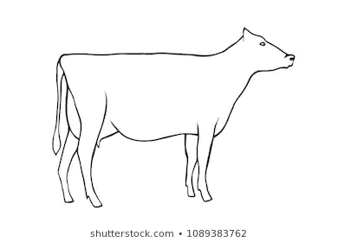
Minerals:
Water:
Protein:
Vitamins:
Fats:
Carbohydrates:

